**Extension List**

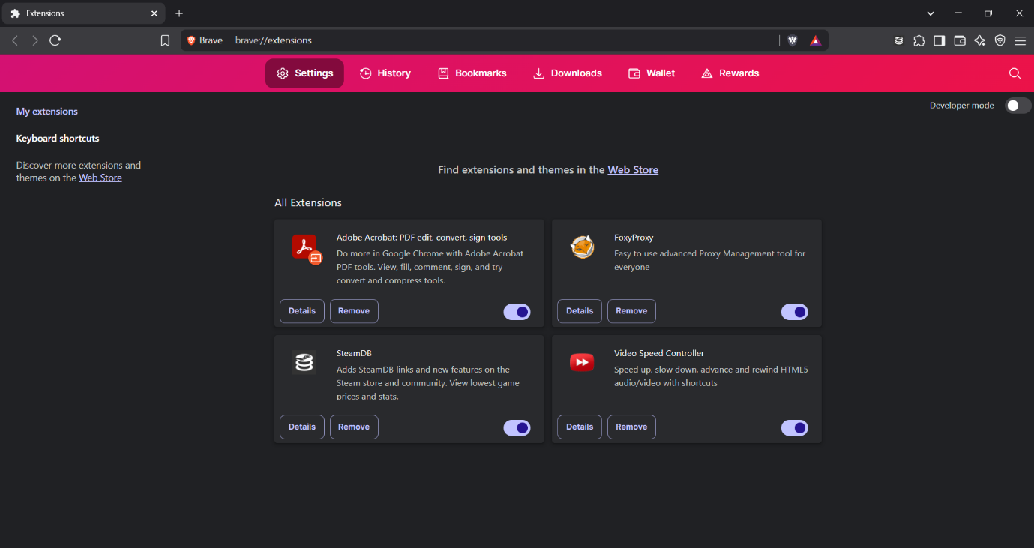

* **Adobe Acrobat: PDF edit, convert, sign tools**
* **FoxyProxy**
* **SteamDB**
* **Video Speed Controller**

**Adobe Acrobat: PDF edit, convert, sign tools**

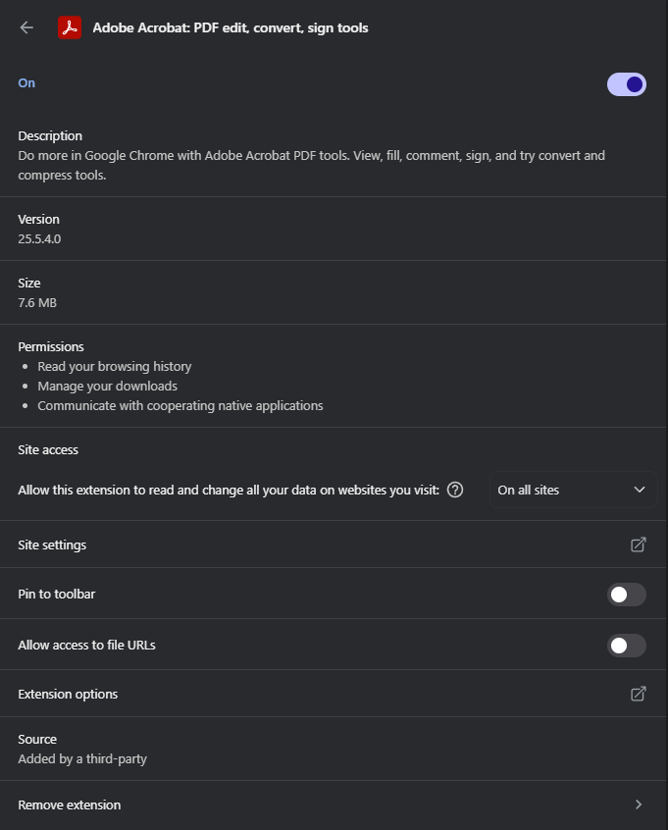

**Version**: 25.5.4.0

**Size**: 7.6 MB

**Permissions**:

* Read your browsing history
* Manage your downloads
* Communicate with cooperating native applications

**FoxyProxy**

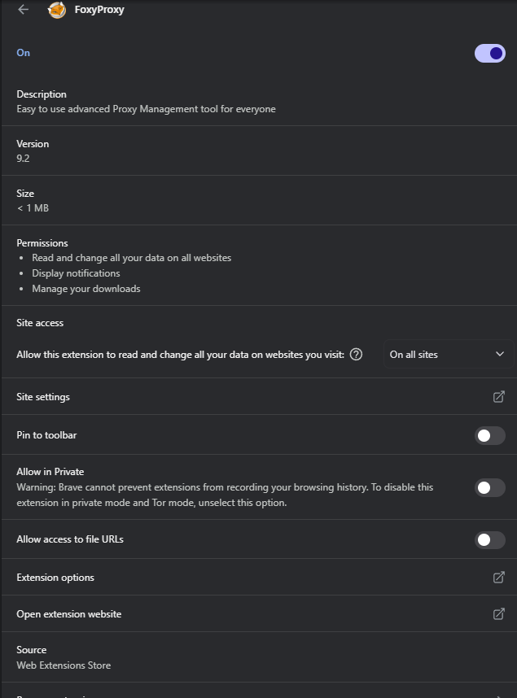

**Description:** Easy to use advanced Proxy Management tool for everyone

**Version**: 9.2

**Size**: < 1 MB

**Permissions**:

* Read and change all your data on all websites
* Display notifications
* Manage your downloads

**SteamDB**

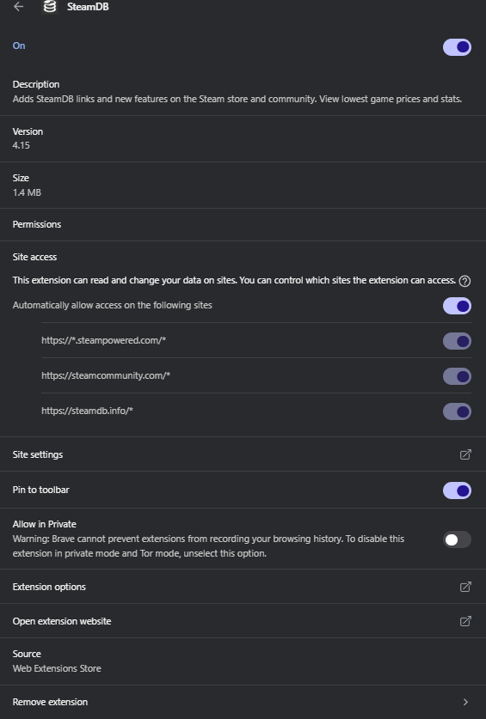

**Description:** Adds SteamDB links and new features on the Steam store and community. View lowest game prices and stats.

**Version**: 4.15

**Size**: 1.4 MB

**Permission:** None

**Site Access**:

* [https://*.steampowered.com/*](https://*.steampowered.com/*)
* [https://steamcommunity.com/*](https://steamcommunity.com/*)
* [https://steamdb.info/*](https://steamdb.info/*)

**Video Speed Controller**

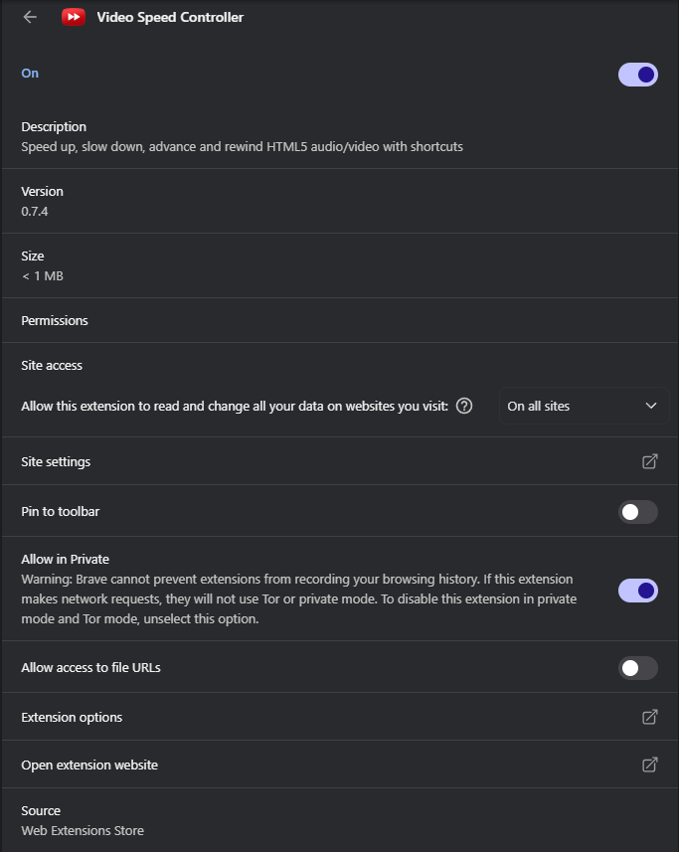

**Description:** Speed up, slow down, advance and rewind HTML5 audio/video with shortcuts.

**Version**: 0.7.4

**Size**: < 1 MB

**Permission:** None

**Site Access**: All

**Extensions Reviewed**

|  |  |  |
| --- | --- | --- |
| Extension Name | Permissions Summary | Verdict |
| Adobe Acrobat | Browsing history, download management, native app communication | Safe – Trusted |
| FoxyProxy | Full access to all website data, downloads, notifications | Safe – Used for BurpSuite |
| SteamDB | No special permissions, limited site access to Steam-related domains | Safe – Trusted |
| Video Speed Controller | No special permissions, access to all sites (typical for video controls) | Safe – Popular Tool |

**Action Taken:**

* Reviewed all installed browser extensions.
* Checked permissions, purpose, and user reviews.
* **No suspicious or unused extensions found.**
* **FoxyProxy** is configured specifically for use with **BurpSuite** during security testing.

**How malicious extensions can harm users:**

* **Data Theft:** Steal passwords, cookies, and personal info by reading web page content.
* **Spy Activity:** Track browsing behavior and send data to attackers.
* **Ad Injection**: Display unwanted ads or redirect to malicious websites.
* **Credential Harvesting:** Fake login forms or keyloggers to capture credentials.
* **System Access**: Exploit permissions to download files or run code.
* **Man-in-the-Browser Attacks:** Modify web pages in real-time (e.g., changing payment details).